Blog site list

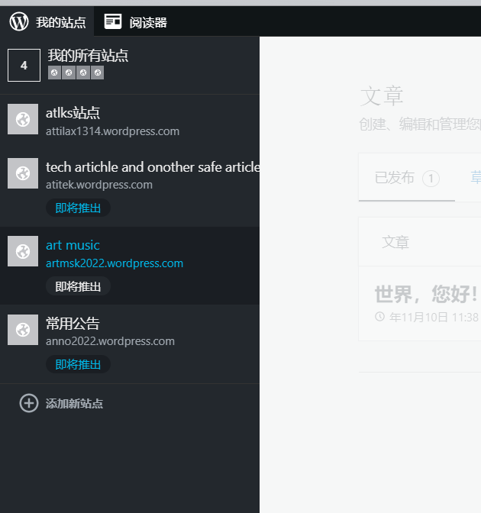

Eml send art setting ,

My center>>mng blog >>

| 博客名称 | 地址 | 主要 | 角色 | 仪表盘 | 统计 | 通过电子邮件发表 | 通过语音发表 |  |
| --- | --- | --- | --- | --- | --- | --- | --- | --- |
| 全选 | 博客名称 | 地址 | 主要 | 角色 | 仪表盘 | 统计 | 通过电子邮件发表 | 通过语音发表 |  |
|  | [atlks站点](http://attilax1314.wordpress.com/wp-admin/) | [attilax1314.wordpress.com](http://attilax1314.wordpress.com/)  [更改博客地址](https://wordpress.com/domains/manage/attilax1314.wordpress.com) [转移博客](https://dashboard.wordpress.com/wp-admin/index.php?page=my-blogs&_wpnonce=839283bbbc&transfer=173399052) |  | 管理员 | 可见性  无法隐藏此博客 | [IMG_256](https://wordpress.com/stats/173399052) | [pile327diji@post.wordpress.com](mailto:pile327diji@post.wordpress.com" \o "p i l e 3 2 7 d i j i)  [vCard](https://dashboard.wordpress.com/wp-admin/index.php?page=my-blogs&_wpnonce=a5cd1c1705&vcard=173399052) | [重新生成](https://dashboard.wordpress.com/wp-admin/index.php?page=my-blogs&_wpnonce=a5cd1c1705&pbe_generate=173399052) | [删除](https://dashboard.wordpress.com/wp-admin/index.php?page=my-blogs&_wpnonce=a5cd1c1705&pbe_delete=173399052) | +1 (713) 574-9075 Enter: ****4598053****  [重新生成](https://dashboard.wordpress.com/wp-admin/index.php?page=my-blogs&_wpnonce=c5d3042050&pbv_generate=173399052) | [删除](https://dashboard.wordpress.com/wp-admin/index.php?page=my-blogs&_wpnonce=c5d3042050&pbv_delete=173399052) |  |
|  | [art music](http://artmsk2022.wordpress.com/wp-admin/) | [artmsk2022.wordpress.com](http://artmsk2022.wordpress.com/)  [更改博客地址](https://wordpress.com/domains/manage/artmsk2022.wordpress.com) [转移博客](https://dashboard.wordpress.com/wp-admin/index.php?page=my-blogs&_wpnonce=8a6f8831fb&transfer=199682099) |  | 管理员 | 可见性  [隐藏](https://dashboard.wordpress.com/wp-admin/index.php?page=my-blogs&_wpnonce=8a6f8831fb&hide_blog=199682099) | [IMG_257](https://wordpress.com/stats/199682099) | [qoko170seje@post.wordpress.com](mailto:qoko170seje@post.wordpress.com" \o "q o k o 1 7 0 s e j e)  [vCard](https://dashboard.wordpress.com/wp-admin/index.php?page=my-blogs&_wpnonce=eb6f089e86&vcard=199682099) | [重新生成](https://dashboard.wordpress.com/wp-admin/index.php?page=my-blogs&_wpnonce=eb6f089e86&pbe_generate=199682099) | [删除](https://dashboard.wordpress.com/wp-admin/index.php?page=my-blogs&_wpnonce=eb6f089e86&pbe_delete=199682099) | +1 (713) 574-9075 Enter: ****9135338****  [重新生成](https://dashboard.wordpress.com/wp-admin/index.php?page=my-blogs&_wpnonce=c9045fa0d2&pbv_generate=199682099) | [删除](https://dashboard.wordpress.com/wp-admin/index.php?page=my-blogs&_wpnonce=c9045fa0d2&pbv_delete=199682099) |  |
|  | [tech artichle and onother safe article](http://atitek.wordpress.com/wp-admin/) | [atitek.wordpress.com](http://atitek.wordpress.com/)  [更改博客地址](https://wordpress.com/domains/manage/atitek.wordpress.com) [转移博客](https://dashboard.wordpress.com/wp-admin/index.php?page=my-blogs&_wpnonce=61c04171d9&transfer=197087738) |  | 管理员 | 可见性  [隐藏](https://dashboard.wordpress.com/wp-admin/index.php?page=my-blogs&_wpnonce=61c04171d9&hide_blog=197087738) | [IMG_258](https://wordpress.com/stats/197087738) | [copu509yoka@post.wordpress.com](mailto:copu509yoka@post.wordpress.com" \o "c o p u 5 0 9 y o k a)  [vCard](https://dashboard.wordpress.com/wp-admin/index.php?page=my-blogs&_wpnonce=8d3d077f2a&vcard=197087738) | [重新生成](https://dashboard.wordpress.com/wp-admin/index.php?page=my-blogs&_wpnonce=8d3d077f2a&pbe_generate=197087738) | [删除](https://dashboard.wordpress.com/wp-admin/index.php?page=my-blogs&_wpnonce=8d3d077f2a&pbe_delete=197087738) | +1 (713) 574-9075 Enter: ****4004858****  [重新生成](https://dashboard.wordpress.com/wp-admin/index.php?page=my-blogs&_wpnonce=808ceae8f7&pbv_generate=197087738) | [删除](https://dashboard.wordpress.com/wp-admin/index.php?page=my-blogs&_wpnonce=808ceae8f7&pbv_delete=197087738) |  |
|  | [常用公告](http://anno2022.wordpress.com/wp-admin/) | [anno2022.wordpress.com](http://anno2022.wordpress.com/)  [更改博客地址](https://wordpress.com/domains/manage/anno2022.wordpress.com) [转移博客](https://dashboard.wordpress.com/wp-admin/index.php?page=my-blogs&_wpnonce=3215102f4d&transfer=199682851) |  | 管理员 | 可见性  [隐藏](https://dashboard.wordpress.com/wp-admin/index.php?page=my-blogs&_wpnonce=3215102f4d&hide_blog=199682851) | [IMG_259](https://wordpress.com/stats/199682851) | [jofi073sige@post.wordpress.com](mailto:jofi073sige@post.wordpress.com" \o "j o f i 0 7 3 s i g e)  [vCard](https://dashboard.wordpress.com/wp-admin/index.php?page=my-blogs&_wpnonce=51b7fea4c8&vcard=199682851) | [重新生成](https://dashboard.wordpress.com/wp-admin/index.php?page=my-blogs&_wpnonce=51b7fea4c8&pbe_generate=199682851) | [删除](https://dashboard.wordpress.com/wp-admin/index.php?page=my-blogs&_wpnonce=51b7fea4c8&pbe_delete=199682851) | +1 (713) 574-9075 Enter: ****2586918****  [重新生成](https://dashboard.wordpress.com/wp-admin/index.php?page=my-blogs&_wpnonce=7fbbe9001f&pbv_generate=199682851) | [删除](https://dashboard.wordpress.com/wp-admin/index.php?page=my-blogs&_wpnonce=7fbbe9001f&pbv_delete=199682851) |  |

Blogger nmlart blog

attilax3.blogspot.com